1. Text

   Description automatically generated
2. **Agenda**:
   1. What is an **API**?
3. Let’s talk about “What is an **API**?” before talking about **OpenAPI Specification**.
4. **API**: Application Programming Interface.  
   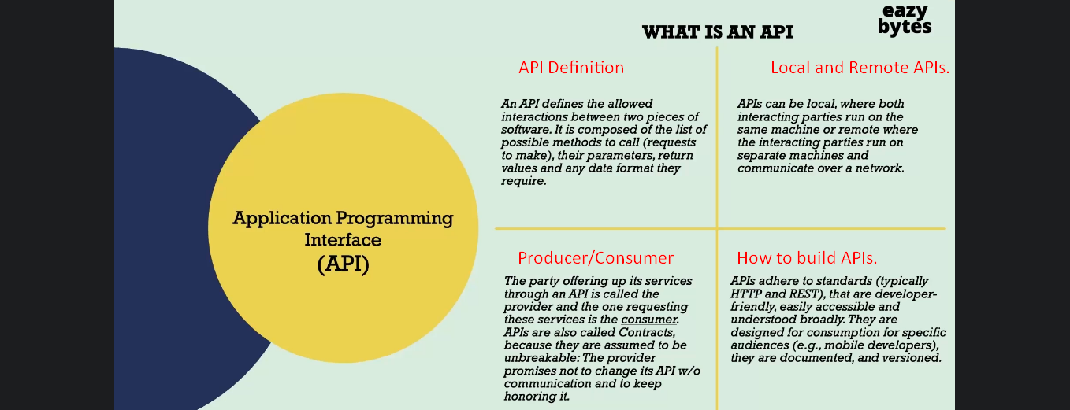
   1. API also defines what is input parameters, what is the request/response structure, request data format.
   2. **Local API Example**:
      1. OS and the Softwares installed on your laptop are a good example for Local API.
      2. With the help of corresponding API of the installed Softwares, the OS calls appropriate API based on the action on UI.
   3. **Remote API Example**:
      1. Two Softwares or Apps deployed on two different Servers can interact with each other through API.
   4. **Producer = Provider & Consumer**:
      1. **Producer**: The party offering the services for the API requests.
      2. **Consumer**: The one using the offered services.
   5. **How to build these APIs**:
      1. Using **HTTP and REST Protocols** because they are lightweight and easy to understand as dominantly used by industry.
5. Let’s have some realtime **examples of APIs**.
   1. Take any **E-Commerce application** like Amazon.  
      On the Payment Page, you are given many Payment Options 🡺 Credit/Debit Card, Paypal, Paytm etc.  
      In these kinds of scenarios, API Communication will happen.  
      Suppose, you choose Paypal.  
      Definitely, Paypal & Amazon are two different Apps in two different organizations.  
      So what might have happened in the background?  
      They might have **API Agreement/Contract** established.  
      Based upon these agreements, when a user clicks on Paypal button, the payment will be processed.  
      Here Paypal is **Provider** & the Amazon is **Consumer**.  
      Diagram

      Description automatically generated
   2. Another example is of **Travelling Booking Website** which lists all the airline details with their options and price details.  
      After you enter all your details, the **Travelling Website** will interact with the external airline applications like Singapore Airline through their APIs and display the response on the screen.  
      Here Travel Booking Website is the **Consumer** and Airline Companies are the **Producer**.  
      Diagram

      Description automatically generated
6. 
7. Graphical user interface, application

   Description automatically generated